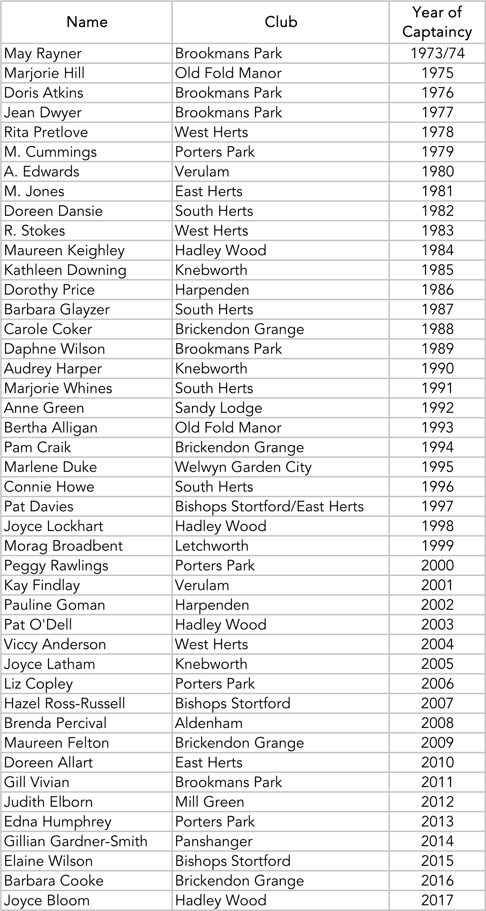

|  |  |  |
| --- | --- | --- |
| Maggie MacCrimmon | Whipsnade | 2018 |
| Anne Spurr | Harpenden | 2019 |
| Val Stickley | Knebworth | 2020 |
| Debbie Osman | Mill Green | 2021 |
| Sarah Brookes | Letchworth | 2022 |
| Jackie Lagergren | Hadley Wood | 2023 |
| Sue Burbidge | Mill Green | 2024 |